# ADVENTURE PART 1

## Swallow’s song

***Play: Medieval Inn Music***

A quaint town backed up to a breathtaking mountain range to the West. A glistening waterfall runs down the mountain and forms a stream that has lead to the success of the town. From water powered mills to unusually high crop growth, the stream has provided the town with everything it needs.

Adventures, academics, and wanderers alike all stop at Swallow’s Song to rest after a long mountainous journey through Storm’s Rage Mountains, or to prepare for the long journey that is still to come. There is a pass adjacent to the city, although still treacherous, it is considerably shorter than any other part of the mountain range.

All of the basic necessities can be found in Swallow’s Song, but specific desires may not be available (i.e. specific temples, etc).

**Ask: What are each of you doing in Swallow’s Song? (both “why are you here” and “what are you currently doing?”)**

**The Inn:**

The inn is run by an older couple without children, Beor and Uma. They are good people and often give discounts to traveler’s they like.

Upon entering the inn, the main dining area is presented. You can purchase food and lodging at the main bar. The bartender/book keeper is Uma, an older lady who also owns the inn.

A few other traveler’s sit in the dining area.

A small group of 3 dwarves drink ale and eat full chickens in the center of the room. They are being very loud and vulgar.

Baern, Harbek and Rurik, from the southern mountains are heading north to a new dwarfing community in Mt. Condor. The small Tiefling village in the south has been extra rowdy and they don’t want to deal with them anymore.

A human traveler in expensive, but tattered cloths sits alone drinking ale.

A beautiful sword is sitting on the table. The traveler looks extremely muscular.

“I don’t know what attacked us, but it reeked of death and wasn’t stopped by swords or arrows. I cut down a few of them, but there were far too many. I decided to flee to Arynsport on the other side of the mountains. Those mountains are dangerous. Extremely deadly to cross for the inexperienced traveler.”

“I got this sword in the war. Those were the days. Nothing was better cutting down your enemies with your brothers, then sharing a few ales and a few tavern girls that night. I got this sword from a rich lord who was grateful that I recused his daughter from rappers. Little did he know I gave her a sword that night, if you get what I mean”

An old man sits alone, his nose in a recording keeping booklet. He is neither eating nor drinking.

Beor is married to Uma, the barkeep. Although he initially doesn’t want to talk because he is busy, he opens up quickly and offers nice traveler’s a 10% discount on food, drink, and lodging.

**The Temples:**

There are two temples in Swallow’s Song, worshiping Ulaa, goddess of the hills and mountains (LG, life/war, mountain with a circle at its heart) and Beory, goddess of nature (N, Nature, green disk).

A church officiant (either temple, doesn’t matter) is talking to a priest about staying another night. The officiant is insisting that the priest does not attempt to go to the Talos Temple in the mountains. They are saying that the weather at the mountain peak is especially bad right now. The priest is insisting that Talos, god of storms, will be kind to him as he has gained favor with the god. The priest thanks the church officiant for the comforts he has provided and takes off for Storm Rage Mountains.

Roll for intelligence(religion) or intelligence(history): You remember hearing about a rare and mystical relic that the Talos priests hid away a thousand years ago. Although you can’t remember fully, it has something to do with traveling between worlds. DC 10

It is nearing twilight and traveler’s begin to find shelter and supper. Those who can afford the 10sp inn charge enjoy the comforts of a warm, clean bedroom, while others may prefer the free but riskier bed of stable straw.

**Ask: What do you do? (i.e. where are you going to sleep)**

A sudden piercing scream echoes through the streets. Inn keepers, smiths, cooks and travelers alike pause in anticipation. More screams reverberate off the twilight lit streets until the sound completely floods the town. A small crowd of people can be seen running from the northern part of town towards the inn.

**Ask: what do you do?**

**IF TOGETHER**

2 men with tattered clothes march towards you, holding various melee weapons. As they grow nearer, the smell of decay fills your nostrils. These men appear to be dead…

***Play: Darkest Dungeon***

**IF NOT TOGETHER**

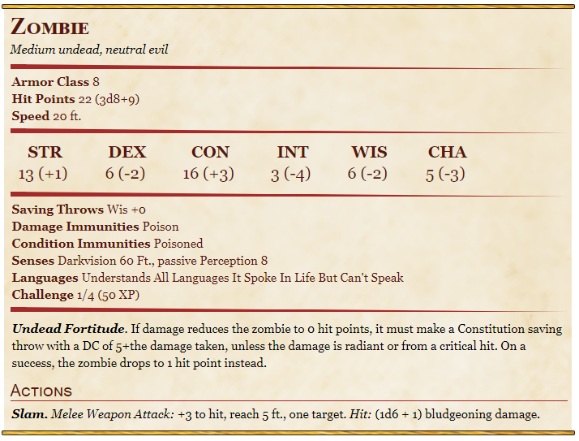

**Ask: What do you do (can run or fight)**

**Trigger combat (Easy)**

1. **Roll for initiative (d20 + dex mod)**
   1. **Highest roll goes first, etc**
2. **See combat print out for what all they can do**
3. **Attacks: roll d20 + provided ability mod + proficiency bonus (if proficient with weapon)**
   1. **If attack roll > enemy armor class = hit**
   2. **If hit, roll d# (depends on weapon) and add ability mod (see img below)**
   3. **Subtract from hit points**
4. **Monster attacks: roll d20 then add +# to hit (i.e. for zombie, +3).** 
   1. **If attack roll > enemy armor class = hit**
   2. **If hit, roll d# + provided modifiers (for zombie, 1d6 +1)**
5. **If monster HP = 0 => It dies (except for zombies)**
6. **If player HP = 0 => You faint. Roll 1d20 each turn**
   1. **If d = 1, +2 fail saves**
   2. **If 9 >= d >=2, +1 fail saves**
   3. **If 19 >= d >= 10, +1 success**
   4. **If d = 20, become stable/has 1 HP**
   5. **+3 success = stable/ has 1 HP**
   6. **+3 fails = dead dead**
   7. **Can still be healed if hasn’t had +3 fails**
7. **Distribute exp**
   1. **Add all monster’s exp (so 1 zombie = 50exp, 2 zombies = 100exp) / num of players**

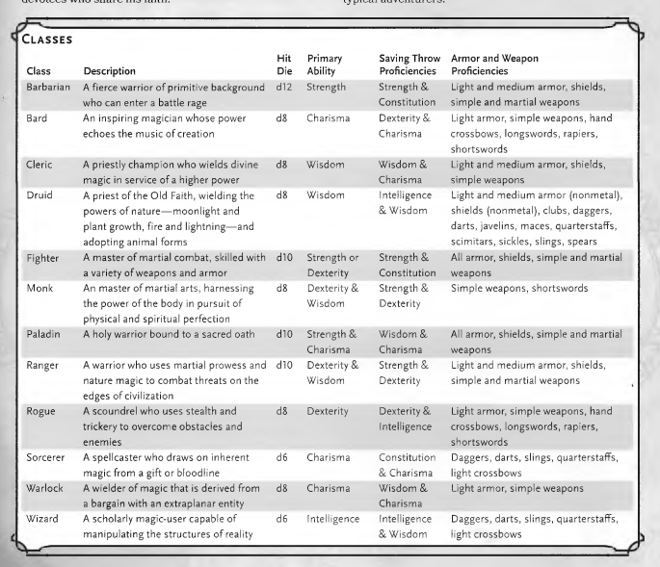

**Notes:**

The 2 undead were easy enough for your group to dispose of. As you look up, you notice the 2 undead soldiers were just the beginning. Dozens more descend onto the town. As you contemplate your next move, a howling screech fills the air. A giant hooded creature swoops down into the streets, destroying shops and homes in its path. The hooded traveler [you noticed] in the inn races to fight it. He expertly swings the giant sword he was carrying to cut down the hooded figured. Without hesitation, the figure collides with the man, and tears open his chest with its long, sharp fingers. The undead hoard quickly flocks to the bloody mess. It seems highly unlikely that sticking around will lead to anything but death.

Intelligence (Arcana) roll to identify wraith as wraith

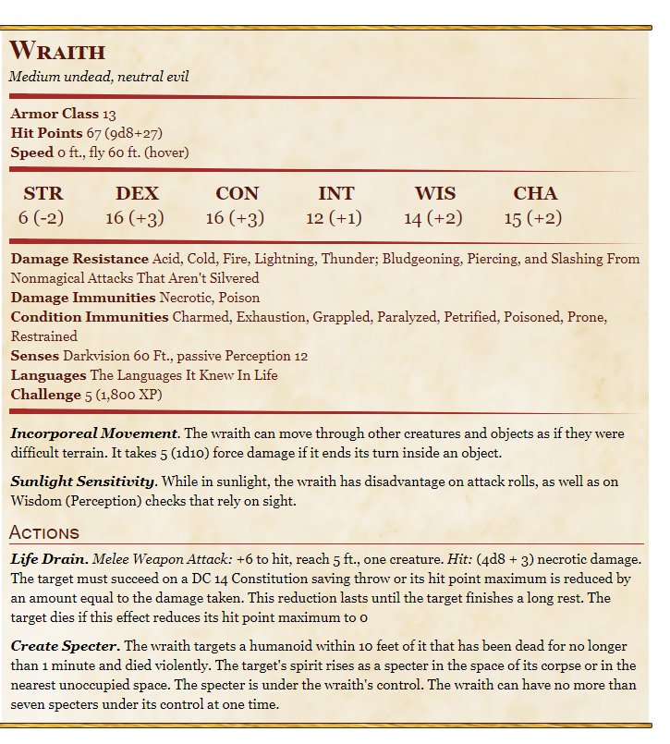

**Ask: What do you do?**

***On run away: play 2 hours of dark music***

***if heads north: more zombies – I will kill you***

***if heads south: a girl suggests heading east towards Silver rose***

***if heads west: impenetrable mountains. Beor, who cant find Uma, suggests going east towards silver rose***

***if heads east: Runs into a farmhouse with provisions. A thick collection of trees obscures the path ahead. There’s no telling what could be hiding in there.***

**Meet and greet if haven’t done so already.**

**Ask: What do you do next?**

If they try to leave during the night, 1d20 Wisdom (Perception) check to see if zombies are outside (they are, but are masked by the darkness, give +1 for darkvision). Easy-ish task so DC is 10 (so must roll d20 + wisdom mod > 10). Higher roll sees more zombies.

If they leave, they can run back into the house and the zombies don’t pursue.

If they try to fight, then initiate combat.

**Very optional combat:**

1 zombie sees them every 5 turns. Force them to retreat – Zombies are not fast.

When they leave during the morning, they may notice that Swallow’s Song is destroyed. Buildings may have been lit on fire or looted after the fact. It appears the town is now abandoned, but the townspeople will more than likely rebuild soon. There are no signs of zombies or other evil creatures.

So now they should head to Silver Rose. It’s going to take 1 day and is 26 miles away (24 miles a day of travel). With a horse, they will get there by nightfall. Without a horse, they will get there after nightfall.

**Say: Mingle amongst yourselves as you travel**

As they walk down the path, the tree line grows thicker and thicker. The sound of a rumbling river fills the air. As you walk, you notice a large bridge up ahead. Blocking the bridge, you notice an older man with 2 horses and a wagon, along with a few other men. The two groups seem to be arguing.

**Say: What do you do?**

As you grow closer, it appears the group of men are bandits!

“Give us your horses and wagon and we’ll be on our way” one sneers at the old man.

“p-p-please,” the old man begs, “if I don’t have my horses, how am I supposed to feed my family”

At that moment, the 4 bandits notice your group approaching.

The begin eyeballing your backpacks and weapons, their eyes filling with greedy.

“Well, aren’t you a good lookin’ bunch,” the bandit says charismatically, “what brings you to my neck of the woods?” *he gestures at the surrounding trees and snickers.

*back and forth talk between group and bandit. Bandit doesn’t want to fight, but wants you to just pass by without any trouble*

“please help me,” the old man stutters.

“QUIET OLD MAN!” the bandit yells, then laughs its off

**Say: do you fight for the old man, or cross the bridge?**

If fight for the old man: the 4 bandits attack, 2 rangers on the other side of the bridge are present but don’t attack for a few turns (they were sleeping)

If try to cross bridge: 2 bandits with bows and a bandit with a club appear from beside the bridge. Their sharp arrows are pointed directly at you. “I’m sorry. I forgot to tell you. There’s a fee for crossing this bridge. 1000gp.” A bandit slits the old man’s throat and takes off with the carriage.

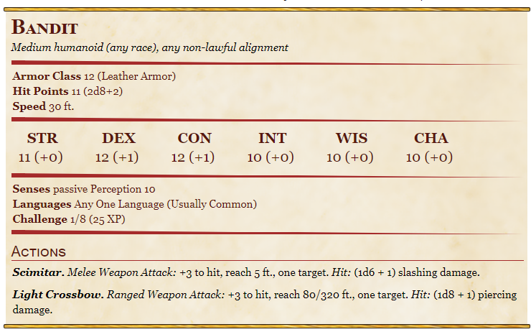

Among the dead men, you find 40gp and a pretty dagger with an ivory and gold handle.

## Silver Rose

**If you helped the old man:** The old man, David, is grateful for the help and offers to take you to Silver Rose. You can make it by night fall, if you hurry. He tells you that he and his wife own an inn, Silver Vine, and he visits the town of Swallow’s Song to get the best bread and freshest apples for his guests.

***Play: Medieval Inn Music***

Once you arrive at his farm house right inside the Walls surrounding the city, he tells his wife what you’ve done. His wife, Mary Margaret, is so happy she gives you a few items that other travelers have left behind:

* Cloak of protection (+1 bonus to AC and saving throws) (requires attunement)
* Boots of Elvenkind (Advantage on stealth checks, walking never makes a sound)
* Elixir of health (removes any disease from you, or blindness, deafness, paralysis, or poison)
* Potion of Invulnerability (for 1 min you have resistance to all damage)

Additionally, they agree to give you free rooms during your visit, and discounts on future visits.

**If you didn’t help the old man:**

The path to Silver Rose is long and consists of rolling flowery hill cascading in tall grass. Although you can see the glimmer of Silver Rose in the distance, you know you are still about an hour away. A faint hiss makes the hair on your neck stand up.

**What do you do?**

5 tiny snakes and 1 giant snake.

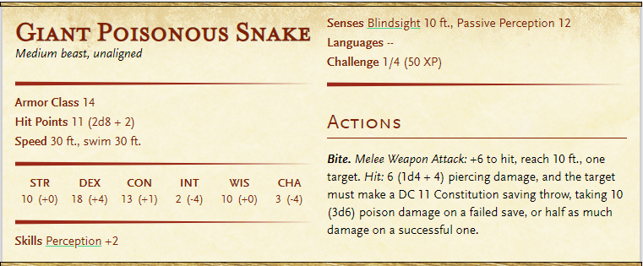

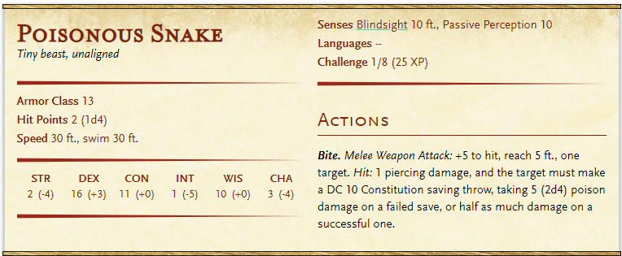

You finally make it to the gates of Silver Rose and are admitted passage. There is an inn almost immediately inside of the gate. You are weary from the battles and the travel.

**Say what do you do?**

Wherever they go, someone (like a scared villager, or a soldier who notices their clothes) talks to them about the undead. They say the heard something about the wood elf village up north in the Temporal Forest….Maybe they know more about it?

**End Campaign 1 _______________________________________________________________________**